# PROOF AND EXPERIMENTAL ESTABLISHMENT (IOS 9001:2015)

The PXE is an Indian defence laboratory of the DRDO (Defence Research and Development Organisation) which usually deals with the research and development of technologies and products in the area of medium and large calibre weapons and their ammunition. This is organised under the armaments director of DRDO.

In March 1894, the first proof testing in India was carried out, with there being fired six inch (152 mm) Bag Loader Howitzers and 12 Pounder Shrapnel shells under the command of Captain R.H. Mahon. He recommended the creation of a dedicated department for this purpose. The Proof Department in India was sanctioned in May 1895.  It was established on November 7, 1895, with headquarters at Balasore and Lt. R.T. Moorre as the head.

Later, the establishment was renamed to the **Proof & Experimental Department**, and later still was renamed as PXE. The establishment was organized under the Director General of Ordnance (DGO), India and subsequently came under the supervision of the Inspection Organization under the DGO. After Independence, PXE was under the administrative control of DGI up to 1958. On July 15, 1947, Lt. Col. B.N. Mitra became the first Indian to head the organization. The establishment was brought under the administrative control of DRDO in October 1958.

PXE is situated on the coast of Bay of Bengal at Chandipur, Odisha at a distance of 15 km from Balasore, which is also the oldest establishment of DRDO. Today, it has reached to a stage to be able to compete in the International Armament Arena and even offering a range of facilities to the friendly foreign countries. The acquired range is 19.5 km in length and approx 3km in width; however this can be extended up to approx 50 km in length towards southwards, along the Bay of Bengal from Chandipur and 50 km into the sea.

The PXE conducts research established for design and development trails of gases, motors, rockets, tanks guns and their ammunitions as well as conducts technical calculations trails for imported weapons and ammunitions and R&A trails for compilation of range tables. PXE has conducted tests for the ARJUN MBI Armour as well as tests of indigenous Explosive reactive armour. The lab has conducted tests on the armaments such as the Indian Field Gun.

The PXE enjoys a lot of facilities such as:

* The crescent shaped sea coast facilitates firing at different bearings into the sea without endangering the coastal inhabitation, neighbouring property.
* Uninterrupted firming on continue simultaneously from all firing points as the line of firms and trajectory don’t intersect and don’t hinder any major highway or sea ways.
* The tidal water recedes to a distance of about 3 km into the sea which facilitates various range workouts before and after the firings.
* Meteorological conditions facilitate dynamic test and evaluation throughout the year.
* Each high tides fill the water up all the crates on the sea bed caused due to landing of the projectiles and levels the sea bed for the next firings.
* During low tides the sea beds becomes sufficiently hard which permits movements of loaded vehicles and even tanks for various range operations.
* It has test facilities for the measurements of range and accuracy of rockets and projectiles, measurements of armour protection levels and testing of proximity fuzes and have labs to measure the ballistic characteristics- Internal, External and Terminal ballistics,

# THEODOLITE

# INTRODUCTION

Theodolite is an device used for the precise measurement of horizontal and vertical angle in surveying and has wide usability in surveying such as laying off horizontal angles , locating points on the line of surveying line establishing grade and determining difference in elevation setting out curves. The theodolites are classified as follows

* Transit Theodolite
* Non Transit Theodolite
* Vernier Theodolites
* Micrometer Theodolite

# USES OF THEODOLITE

* Mapping applications and in the construction industry
* Mapping applications and in the construction industry
* Measurement of magnetic bearing of lines
* Locating points on line
* Locating points on line
* Determining difference in elevation
* Setting out curves
* Aligning tunnels
* Mining works etc.

# MAIN PARTS OF THEODOLITE

1. Upper Plate: It is the base on which the standards and vertical circles are placed. For the most precise reading the upper plate must be perpendicular to the alidade (the part of Theodolite that rotates around vertical axis and bears the horizontal axis of telescope) and parallel to the trunnion axis .
2. Telescope: It has the same feature as in a level graticule with eyepiece and internal focussing for the telescope itself.
3. Vertical Scale: It is a full 400g scale. Its main use is to measure the angle between the line of sight of the telescope and the vertical axis .
4. Vertical Clamp and Tangent Screw: This is the part that usually allows for the free transiting of telescope. The telescope can be slowly transited using the vertical tangent screw when clamped.
5. Lower Plate: It is the base of whole instrument which houses the foot screw and the bearing for the vertical axis.
6. Horizontal Scale (Circle): This is often paced between the upper and lower plates which is capable of a full independent rotation around the trunnion axis and is a full 400g scale.  
   The upper horizontal clamp and tangent screw are usually used during sequence of horizontal angle measurements.
7. Lower Horizontal Clamp And Tangent Screw: This is used to start the horizontal angle measurement to set the 1st reading as 0.

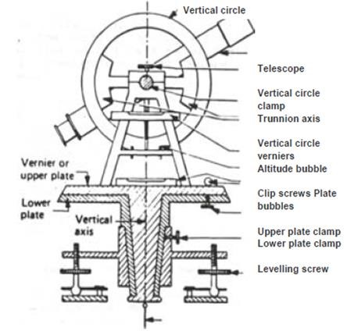

Figure 1: The Theodolite

# MEASUREMENTS

* Horizontal angles
* Vertical angles

# MEASUREMENT OF HORIZONTAL ANGLE

* The instrument is set over B.
* The lower clamp is kept fixed and upper clamp is loosened. Turn the telescope clockwise set Vernier A to 0° and Vernier B to approximately 180°.
* Upper clamp is tightened and using the upper tangent screw the Vernier A and B are exactly set to 0° and 180°.
* Upper clamp is tightly fixed, lower one is loosened and telescope is directed towards A and bisects the ranging rod at A.
* Tightened the lower clamp and turn the lower tangent screw to perfectly bisect ranging rod at A.
* Loose the upper clamp and turn the telescope clockwise to bisect the ranging rod at C tightened the upper clamp and do the fine adjustment with upper tangent screw.
* The reading on Vernier A and B are noted. Vernier A gives the angle directly and Vernier B gives the reading by subtracting the initial reading (180°) from final reading

There are 3 methods of measuring horizontal angles

1. Ordinary method
2. Repetition method
3. Reiteration method

# ORDINARY METHOD

1. Set up the Theodolite at station point O and level it accurately.
2. Set the Vernier A to the zero or 3600 of the horizontal circle. Tighten the upper clamp.
3. Loosen the lower clamp. Turn the instrument and direct the telescope towards A to bisect it accurately with the use of tangent screw. After bisecting accurately check the reading which must still read zero. Read the Vernier B and record both the readings.
4. Loosen the upper clamp and turn the telescope clockwise until line of sight bisects point B on the right hand side. Then tighten the upper clamp and bisect it accurately by turning its tangent screw.
5. Read both Verniers. The reading of the Vernier a which was initially set at zero gives the value of the angle AOB directly and that of the other Vernier B by deducting 1800 .The mean of the two Vernier readings gives the value of the required angle AOB
6. Change the face of the instrument and repeat the whole process. The mean of the two Vernier readings gives the second value of the angle AOB which should be approximately or exactly equal to the previous value.
7. The mean of the two values of the angle AOB ,one with face left and the other with face right ,gives the required angle free from all instrumental errors**.**

# REPETITION METHOD

1. Set up the Theodolite at starting point O and level it accurately.
2. Measure the horizontal angle AOB.
3. Loosen the lower clamp and turn the telescope clock – wise until the object (A) is sighted again. Bisect B accurately by using the upper tangent screw. The verniers will now read the *twice* the value of the angle now.
4. Repeat the process until the angle is repeated the required number of times (usually 3). Read again both Vernier .The final reading after *n repetitions* should be approximately n X (angle). *Divide* the *sum* by the *number of repetitions* and the result thus obtained gives the *correct value of the angle* AOB
5. Change the face of the instrument. Repeat exactly in the same manner and find another value of the angle AOB. The *average* of two readings gives the required precise value of the angle AOB**.**

# REITERATION METHOD

1. Set up the instrument over station point O and level it accurately.
2. Direct the telescope towards point A which is known as referring object. Bisect it accurately and check the reading of Vernier as 0 or 360 degree. Loosen the lower clamp and turn the telescope clockwise to sight point B exactly. Read the Vernier again and the mean reading will give the value of angle AOB.
3. Similarly bisect C & D successively, read both Verniers at- Procedure. Each bisection, find the value of the angle BOC and COD.
4. Finally close the horizon by sighting towards the referring object (point A).
5. The Vernier A should now read 3600. If not note down the error .This error occurs due to *slip* etc.
6. If the error is small, it is *equally distributed* among the several angles .If *large* the readings should be *discarded* and a new set of readings be taken**.**

# MEASUREMENT OF VERTICAL ANGLE

A vertical angle is an angle between the inclined line of sight and the horizontal. It may be angle of elevation or depression according as the object is above or below the horizontal plane.

**To Measure The Vertical Angle of an object A at a station O:**

1.  Set up the Theodolite at station point O and level it accurately with reference to the altitude bubble.
2. Set the zero of vertical Vernier exactly to the zero of the vertical circle clamp and tangent screw.
3. Bring the bubble of the altitude level in the central position by using clip screw. The line of sight is thus made horizontal and Vernier still reads zero.
4. Loosen the vertical circle clamp screw and direct the telescope towards the object A and sight it exactly by using the vertical circle tangent screw
5. Read both Vernier on the vertical circle, the mean of the two Vernier readings gives the value of the required angle.
6. Change the face of the instrument and repeat the process. The mean of the two Vernier readings gives the second value of the required angle.
7. The average of the two values of the angles thus obtained is the required value of the angle free from instrumental errors**.**

**For measuring Vertical Angle between two points A &B.**

1. Sight A as before , and take the mean of the two Vernier readings at the vertical circle. Let it be α
2. Similarly, sight B and take the mean of the two Vernier readings at the vertical circle. Let it be
3. The sum or difference of these dings will give the value of the vertical angle between A and B according as one of the points is above and the other below the horizontal plane. Or both points are on the same side of the horizontal plane.

# SOURCE OF ERRORS

INSTRUMENTAL ERRORS

* Non adjustment of plate bubble
* Line of collimation not being perpendicular to horizontal axis
* Horizontal axis not being perpendicular to vertical axis
* Line of collimation not being parallel to axis of telescope
* Eccentricity of inner and outer axes
* Graduation not being uniform
* Verniers being eccentric

PERSONAL ERRORS

NATURAL ERRORS

* High temperature causes error due to irregular refraction
* High winds cause vibration in the instruments, as a result the readings get wrong on vernier.

# THE BREIF DESCRIPTION OF A THEODOLITE

* NAME OF THE INSTRUMENT : Theodolite total station series 30R
* SOURCES : Sokkia, Japan
* ENTRY TO SERVICE: November 2005
* COST: 4.5 lakhs(approx.)
* APPLICATION :

This is used for land survey, distance and angular measurement .

* TECHNICAL SPECIFICATION
  + TYPE : series 30R
  + ACCURACY :”
  + FEILD OF VIEW : 1º30´
  + MAGNIFIACTION :30X
  + OPERATION TEMPERATURE: 20℃to 50℃
  + POWER SOURCE : 6V
* DESCRIPTION :

It is reflection less and offers unprecedented measurement performance without a reflector. It is faster, more accurate and reliable measurement that can be carried out in diverse situation. The series 30R visible laser is extremely narrow and it can pin point thin objects, edge of walls or the target located at a steep angle and even measures through fences or tree branches.

# RADAR

# INTRODUCTION

External ballistics is the study of the motion of projectiles through an external medium. This plays a very pivotal role in the motion of projectile which in turn becomes synonymous with aeroballistics. A large no of modelling and testing is necessary to determine the aerodynamic coefficient of any particular type of ammunition during its testing and designing. In its development phase, in order to get the corrective action in the design, there is a need to get the maximum detailed information about the object’s behaviour when it flies through the trajectory of the projectile. On the later stage, the parameter such as shape, size, muzzle velocities and the spin rate are defined with the main aim to determine the aeroballistics parameter used for the particular design.

If the point mass model is adequate, the best model can be determined by means of radar measurements whereas the six degree of freedom model and the modified point mass model require additional tests (aeroballistics range, wind tunnel).

# RADAR SYSTEM

There are two categories of the radar:

* Pulse tracking radar
* Continuous wave : Doppler radar

|  |  |
| --- | --- |
| PULSE TRACKING RADAR | DOPPLER RADAR |
| * This includes MTI(Motion Tracking Indicator) * This can be set up anywhere as long as it can see the entire trajectory. Thos is physically large in order to measure the long range measurements and therefore are usually made static at a particular position, where it can overlook an entire firing range with several test sights * The results are the position data as a function of time such as vertical angle, azimuth angle and distance according to which the coordinates of the muzzle velocity are further calculated. * While measuring the long range measurement with high transmitting power, pulse radar needs only one antenna as this doesn’t receive during transmission. | * This includes an indicator * This needs to be set up close to the origin of the trajectory and behind the weapon in order to give the maximum accuracy * The primary result is the velocity as a function of time in order to calculate the acceleration when needed. Therefore, velocity and acceleration can be calculated with high accuracy and resolution; the final results therefore include detailed information on velocity and velocity changes. * While measuring the long range measurement with high transmitting power, Doppler radar needs only 2 antenna as this receives and transmits at the same time. |

High flexibility and high efficiency at a firing range can therefore be obtained by combining the two systems in such a way that the Doppler radar can be slaved by the pulse tracking radar.

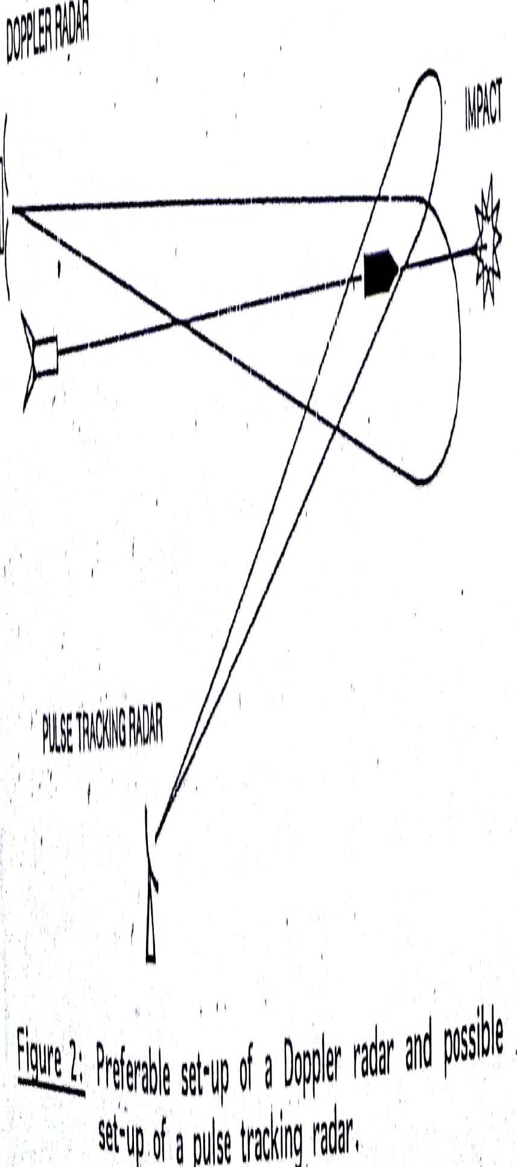

# MEASURING RANGE

The continuous wave Doppler radar system with separate antennas for transmitting and receiving will be used as a reference for calculating the measuring range. The performance of such system is determined by factors relating to:-

* The radar transmission (the illuminator )
* The measuring object
* The radar receiver
* The distance between the radar and the object ( the measuring range).

The transmitter and transmitting antenna act as a illuminator illuminating the target with RF energy, while the receive along with receiving antenna act as detector detecting the scattered energy from the target along the direction of antenna unit.

For a given radar system the range can be found from the following equation :



**where**

**P=transmitter power**

**G=antenna gain**

**λ=wavelength**

**σ=Radar cross section**

**k=Boltzmann constant**

**T=receiver temperature**

**F=receiver noise figure**

**B=filter noise bandwidth**

**(S/N)=Signal to noise ratio**

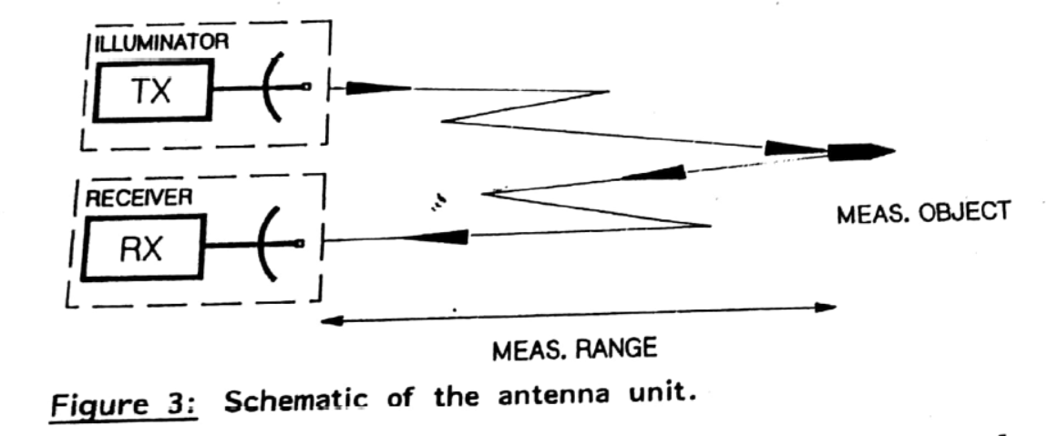

**Figure: schematic of the antenna unit.**

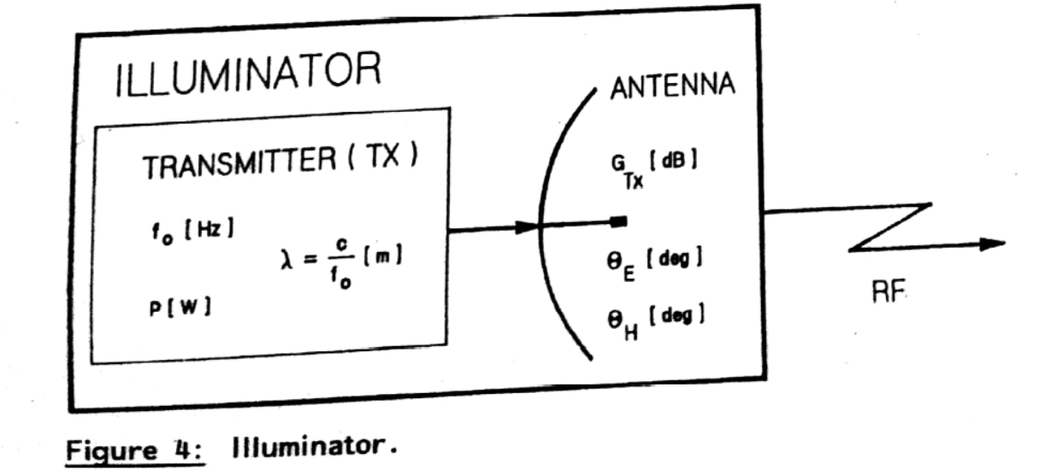

**Figure: Illuminator**

If the antenna is a point source, the energy will be transmitted equally in all directions. In one particular direction the power density P’ can be calculated as function of distance R

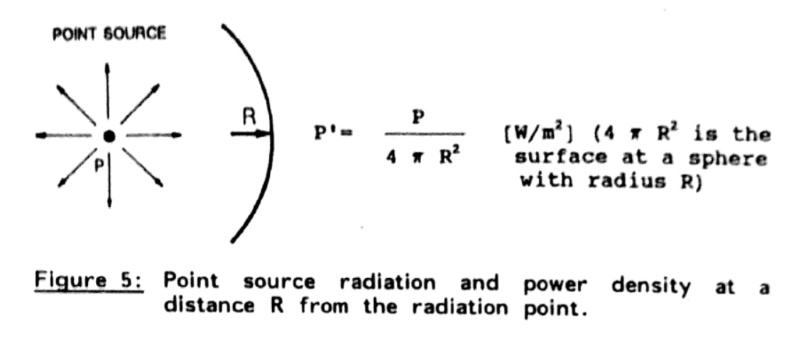

**Figure: Point source radiation and power density at a distance R from the Radiation point**

A more sophisticated antenna with antenna GTX  is used instead of a point source which concentrates and directs the RF energy in the required direction towards the target and the antenna adds directivity and thus the power gets increased by the factor GTX.

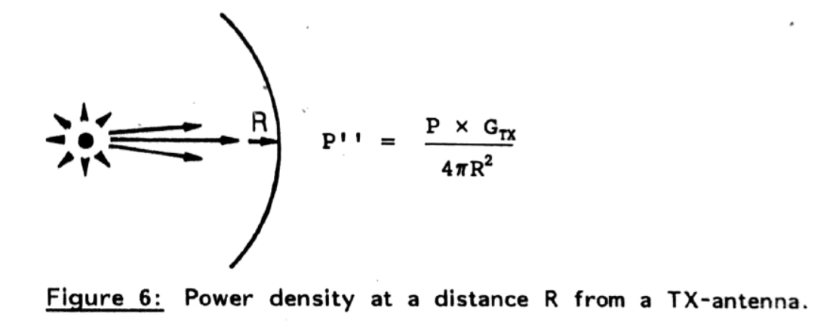

If the target is located at the distance R from the antenna unit , the power density will be equal to the one mentioned in figure 6

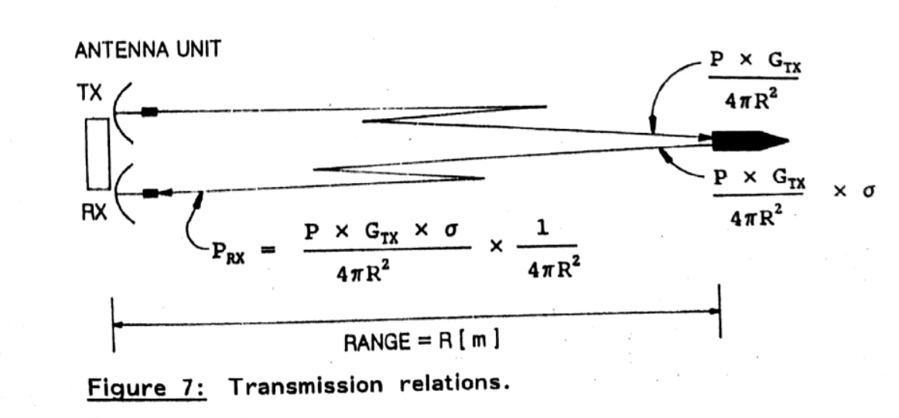

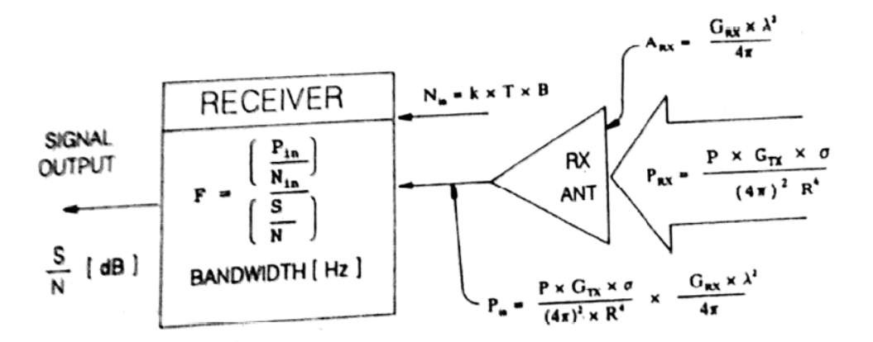

**Figure 8: Receiver.**

# THE BREIF DESCRIPTION OF A DOPPLER RADAR BASED ON POSITION AND VELOCITY TRACKER

* NAME OF THE INSTRUMENT: Long range velocity and position tracking Doppler Radar DR-6700.
* SOURCE: M/S Terna Electronics ,Denmark
* ENTRY TO SERVICE: 1998
* COST: Rs 3.8 Crore(approx)
* PRINCIPLE:
  + This is an ‘S’ based, mobile continuous wave Doppler radar with a micropluse technique that can be used to measure the radial velocity in real time and the elevation of the target. The online tracking can be performed on one target only but this facilitates for the multilayer tracking during its post firing analysis provided the radial velocity differed by a few meters per second for all individual targets
  + This system can measure both the targets approaching the radar as well as those moving away from the radar simultaneously.
* SYSTEM COMPRISES OF:
  + Monopulse training/receiving Antenna ED6700 mounted on trailer.
  + DR6700 Data Unit
  + ET6700 Calibration Unit
* TECHNICAL SPECIFICATION:
  + ED6700 Tx-Rx Antenna
    - TYPE: Stacked Micro Strip patch array
    - CENTER FREQUENCY: 2.63GHz/2.45GHz
    - GAIN: 31.5dB
    - POLARISATION: Vertical
    - BEAM WIDTH: H5.2’ * V3.6’
    - TRANSMITTING POWER: 240 Watts
* Receiver :
  + TYPR: Coherent I.Q Receiver
  + NOISE FIGURE: <3dB
  + OUTPUT: 6 Doppler Signal
  + BANDWIDTH: 0.3 -120KHz
* Data Unit;
  + Flat Panel Colour Display
  + Keyboard including Roller halt
  + 486 DX4 processor system
  + Single Channel
  + DA7 Tape Streamer
  + 1.44MB 3.5”FD
  + Mass Storage HDD Board,340-504 MB
* DATA PROFILE AND PRESENTATION:
  + On line Track Data :
    - Velocity
    - Elevation
    - Azimuth
    - Signal to Noise ratio
* Off line Track Data
  + Time
  + Spin
  + Velocity
  + Signal to Noise Ratio
  + Acceleration
  + Elevation of Target
  + X-Distance, Y-Distance, Z-Distance
* OPTIONAL PARAMETERS:
  + Muzzle Velocity
  + Maximum Velocity
  + Burn time for Rockets
  + Impact point
  + Spectrum
  + DOT Plot

# HIGH SPEED VIDEOGRAPHY AND PHOTOGRAPHY

# INTRODUCTION

Videography refers to the process of capturing moving images on electronic media and even streaming media. Photography is the science, art, application and practice of creating durable images by recording light or other electromagnetic radiation either electronically by means of an image sensor or chemically by means of a light sensitive material such as photographic film.

High speed photography is a photochemical process with which a permanent record can be obtained of a phenomenon occurring too rapidly to be observed visually or to be recorded by conventional photographic techniques. It is the science of taking pictures of very fast phenomenon. In 1948 the society of motion picture and Television Engineers (SMPTE) defined high speed photography as any set of photographs captured by a camera capable of 69 frames per second or greater and of at-least three consecutive frames. High speed photography can be considered to be the opposite of time lapse photography. It also refers to both the meanings

* The first is that the photograph itself may be taken in a way as to appear to freeze motion to reduce the motion blur. This requires a sensors with a good sensitivity and either a very good shuttering system or a very fast strobe light.
* The second is that a series of photographs may be taken at a high sampling frequency or frame rate. This requires some means of capturing successive frames, either with a mechanical device or by moving data off electronic seasons very quickly.

The high speed Videography, invented in 1968, provided methods for recording any rapid movement not visible to the naked eyes on to a magnetic medium. The primary objective of both Videography and photography in the study of motion is to supplement the visual process through the medium of time magnification. The moving objects are to be captured with an accurately known magnification and to get pictures of adequate definition and clarity. In high speed videography images can be viewed in real time and analysed with virtually no delay in comparison to high speed photography.

High speed videography has 2 stages:

* 1st stage: Acquisition, Transmission and storage of a high bandwidth medium.
* 2nd stage: Playback and Study of the images at reduced bandwidth

Thus high definition videography requires very high bandwidth for the operation of the system.

# CHARACTERISTICS OF THE STANDARD VIDEO IMAGING

* NO OF FUNDAMENTAL INFORMATION POINTS ‘PIXEL’’ Pi OF VIDEO IMAGE = Li* N
* NO OF PIXELS OF THE FIELD Pt = Lt * N  
   where Lt = no of lines of the field  
   Li = horizontal scanning lines

N = no of points in each lines

* Scanning directions are from left to right for line or horizontal scanning and from top to bottom for field or vertical scanning.
* Video imaging is formed by a succession of odd no. of lines (1,3,5,...) interposed with a succession of even no (2,4,6,...) known as ***interlacing*** .
* Interlaced video imaging is the combination of half odd no of field and other half of even no. of field.
* Ti = 2Tt where Ti = Time to scan the interlaced image  
   Tt = Time to scan a field
* 625 lines interlaced image in 1/25 sec. Each field of 312.5 lines (European STD)
  + NTSC - 525 at 60Hz ;
  + PAL - 625 at 50Hz;

# HIGH SPEED VIDEO

* Video band width: no of pixels per field * field rate
* Compromise between field rate & quality of video field
* Rapid setting of the equipment at the test site
* Immediate diagnosis of test recorded
* Recording the phenomenon or several minutes.
* Instead of 400000 pixels of broadcasting video, the limit in HS video is 200*200pixels/frame. Increase of bandwidth from 5MHz to 50 MHz

# HIGH DEFINITION BROADCASTING VIDEO (HDTV)

* Developed by Sony – no. of pixels in order of millions, with very high bandwidth  
  Used as CCTV
* Very high quality interlaced images

# INSTANT VIDEO

* It complements HS video, confined to very limited no of images

# DIFFERENCE BETWEEN HIGH SPEED PHOTOGRAPHY and HIGH SPEED VIDEOGRAPHY

|  |  |  |
| --- | --- | --- |
| ***ANALYSIS OF OBSERVED PHENOMENON*** | In variable delay in Results | In near real time |
| ***OPERATOR*** | Specialist | Non-specialist |
| ***IMAGE QUALITY*** | Excellent | Good |
| ***SIZE OF IMAGE*** | Large | Very large |
| ***CHOICE OF SPEEDS*** | Great | Limited |

# DIFFERENT TYPES OF CAMERAS USED

|  |  |  |  |
| --- | --- | --- | --- |
| **SL.NO** | **CAMERAS** | **Max.PPS** | **MODE** |
| **1** | **16 mm cameras**  **1.FASTAX**  **2.HIMAC** | **16000**  **8000** | **Framing**  **Framing** |
| **2** | **35mm cameras**  **1.PHOTOSONICS (4ML)**  **2.PHOTOSONICS (4C)** | **200**  **3500** | **Framing**  **Framing** |
| **3** | **70 mm cameras**   1. **PHOTOSONICS** | **300** | **Framing** |
| **4** | **High Speed Videos**   1. **NAC 200** 2. **SPEED CAM PRO** | **200**  **1000-4000** | **Framing**  **Framing** |
| **5** | **VHS VIDEOS**  **1.PANASONIC M-9000**  **2.PANASONIC M-7**  **3.SONY HANDY CAMS**  **4.SONY BETA CAM**  **SYSTEMS** | **25**  **25**  **25**  **25** | **Framing**  **Framing**  **Framing**  **Framing** |

# ADVANCES IN HIGH SPEED PHOTOGRAPHY

High speed photography, in addition of videography and photonics imaging, has a broad application in all discipline of science and engineering. Over evolution of high speed cameras, these are classified into 7 groups:

* High speed intermittent cameras
* High speed rotating prism cameras
* Rotating mirror cameras
* Roster cameras
* Short duration sparks, flashes and laser pulses
* Kerr cell shutters
* Cameras using electron options

In case of intermittent cameras, the film moves in steps and its motion is governed by the claw mechanism which leads to very high spatial resolution but low temporal resolution with the maximum speed limited to 1000 pps.

Rotating –prism cameras , which is the 2nd generation high speed cameras, plays a major role in the present scenario where the film moves in a continuous manner and the image displacement is compensated by rotational movement of prism.

Rotating mirror cameras reach multi-million pps. Here the limitation is there in the writing speed due to the mechanical movement of mirror but considering both spatial and temporal resolution in to the account it’s better choice than image converter camera.

This gives a short analysis of the advantages and disadvantages of all the cameras thus showing that all these are complimentary to each other in terms of ultra-high speed phenomenon. The advancement in the system helps to record a dynamic sequence of events in a framing mode. The specially designed beam splitters is used which divides the incoming light from single optical input to eight channels associated with micro channel plate intensifier followed by CCD sensor. Variable exposure, interference time and gain for each individual channel are computer programmable. Fiberoptic communication facilitates high speed data transfer between the cameras and computer, which eliminates signal degradation and interference. The trend in high-speech photography and photonics is more towards its applications and finding out different techniques than to go for designing of new high speed cameras.

# VHF WIRELESS COMMUNICATION

# INTRODUCTION

The VHF (Very High Frequency), communication system ranges from 30MHz to 300MHz. In PXE the band range of 146MHz to 174MHz is used. The VHF communication is based on electromagnetic wave principle where electromagnetic wave is electrical energy in nature that has escaped into free space in form of electromagnetic or radio wave.

In PXE range the VHF is used for communication between firing points in one observation point to another observation point with the help of walkie-talkie or base system

The following equipments are used for VHF communication

* GP330,338: GROUND PORTABLE WALKIE-TAKIE
* GM 300: GROUND MOBILE 300(BASE SYSTEM)
* GR 300: GROUND REPEATER 300 (REPEATER STATION)
* RG 59: COAXIAL CABLE

The PXE users use GP 300 for main network of a VHF subnet of a firing important alternative for simplex or semi-duplex mode of communication. The user of long range firing group uses GM 300 for better strength of VHF communication system.

# THEORY

In VHF communication, a Transreceiver pair used to transmit and receive electromagnetic signal with the help of single equipment.

Local oscillator

Power Supply

Voltage Amplifier

Power Amplifier

Speaker

Microphone

AF Speech Amplifier

Modulation

Detector

IF Amplifier

Mixer

Power Supply

Frequency Multiplier

Modulation

Duplexer

Buffer

RF Oscillator

RF Power Amplifier

# WALKIE-TALKIE

A walkie-talkie (known as Handheld Transreceiver) is a handheld, portable two way radio Transreceiver. It includes a half-duplex channel and a push to talk switches that starts transmission. Typical walkie-talkie resembles a telephone handset slightly larger but still a single unit, with an antenna sticking out of the top. The PXE, Chandipur they use a 16 channel Walkie-Talkie whose battery capability is 7.5 volt.

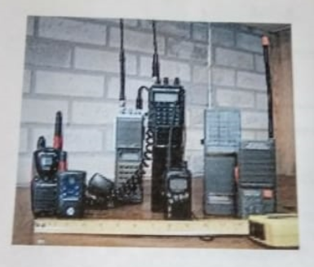

Figure: Walkie-Talkies

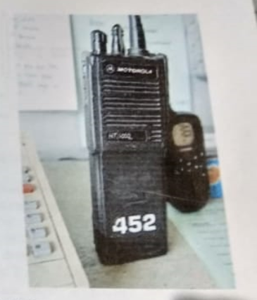

Figure: Walkie-Talkie

# RADIO REPEATER

A repeater is an automated radio station that extends the range of the communication. It consists of a receiver tuned to one frequency and a transmitter tuned to a different frequency, linked together with a controller device. To use a repeater, a user radio is configured to receive on the repeaters transmitting frequency and when we push to talk button is pressed, transmit on the repeater frequency. These are usually installed on top of all tall buildings or mountains and are equipped with an efficient antenna system to receive weak signals and transmission coverage. They extend the effective communication range of a low power handled radio to dozens or may be hundreds of miles. They are usually linked together to further extend the range of communication which is done with wires or a radio link or a phone connection or in the internet using digital audio technology.

The parts of repeaters are

* ANTENNA: It is used to receive and transmit signals that are going into and out of the repeater. It usually gives a high performance, heavy duty and very efficient antenna located at high on a tower or structure.
* FEEDLINE: The feed line used on most repeaters is just not a piece of standard co axial cable. The hard line is used which is very similar to TV line that we see strung between power polls.
* DUPLEXER: It serves a major role in the repeater. It separates and isolates the incoming signal from outgoing and vice versa.
* RECEIVER: It receives the incoming signals. It is generally a high sensitive device and a selective one which receives and helps weaker signals to be heard well by the repeater. It is set to repeat the input frequency.
* CONTROLLER: It is the brain of the repeater which handles repeater station ID using CW or voice activates the transmitter at the appropriate times.
* TRANSMITTER: It as repeater sometimes has a transmitter composed of an exciter and a power amplifier. The exciter modulates the audio coming from the receiver which is tuned to the transmitting station frequency.

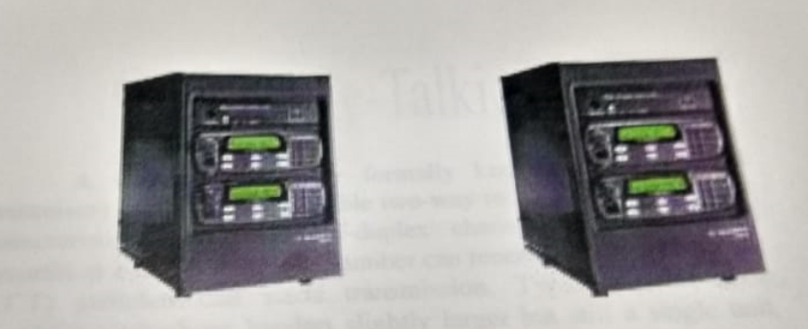

Figure: Radio Repeaters

# BASE STATION

The term base station can be used in the context of land surviving, wireless computer networking and wireless communication. Here at every firing point there is one base station from where one officer can contact with each and every person present there

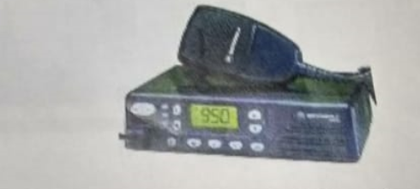

Figure: Equipment used in the base station

## COAXIAL CABLE

It is an electrical cable consisting of an inner conductor surrounded by insulating spacers, surrounded by an outer cylindrical conductor. They are often used as a transmission line for radio frequency signals. In a hypothetical ideal coaxial cable the electromagnetic field carrying the signals exists only in the space between the inner and outer conductor. But the practical ones achieve this objective to a high degree. They provide protection of signals from external electromagnetic interface and effectively guides signals with low emission with low emission along the length of cable. The design choice affects the physical size, frequency performances, attenuating and power handling capabilities, flexibilities and cost. The inner conductor may be silver plated. Sometimes copper plated iron wire is used as an inner conductor. The insulators surrounding the inner conductors may be solid plastic, foam plastic or may be air with space bars supporting the inner wire. The common choice is solid polythene insulators. The insulating jackets are usually made of PVC but application may require fire resistance materials too. Connections to the end are usually made with RF connectors. In PXE we use BASEBAND coaxial cables with impedance of 70 Ohm.

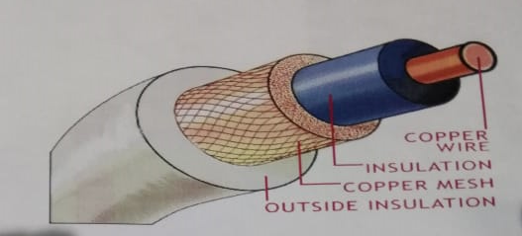

Figure: Coaxial Cable